Roskassa payment module for CMS NetCat 6.x

1. Move the netcat folder to the root of the project.
2. In the administrative panel, open the "Tools -> SQL Command Line" menu.

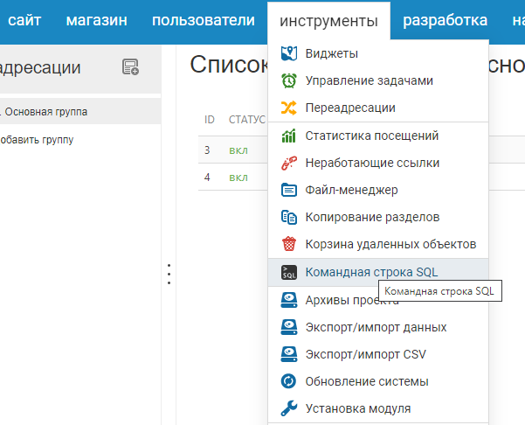

1. Copy the contents of the install.sql file and click "Send request"

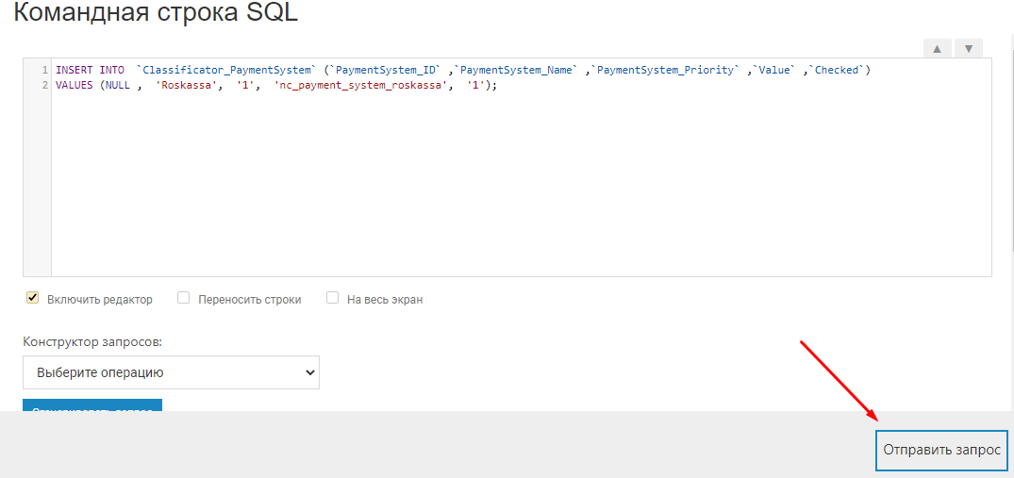

1. Copy the contents of the files in the language folder to the corresponding files in the / netcat / modules / payment / directory
2. Go to "Settings-Take payments"

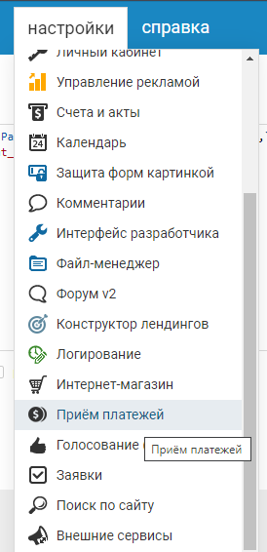

1. Find Roskassa in the list and activate it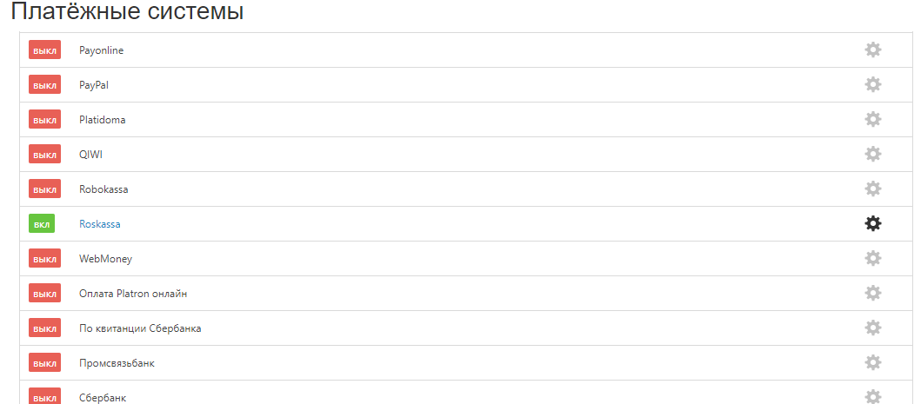
2. Go to the module settings by clicking on the gear on the right.
3. Provide data from your personal account Roskassa.

SHOP_ID-identification number of your store in Roskassa.

SECRET_KEY is the secret key generated in the Roskassa personal account.

LOG_FILE-log, which records data about payments. Here you can change the path to it, by default it is ‘/ roskassa.log’.

ADMIN_EMAIL-email of the administrator.

TEST-enable and disable the test mode of payments.

1-test mode enabled.

0-test mode disabled.

1. After filling in the data, click "Save".

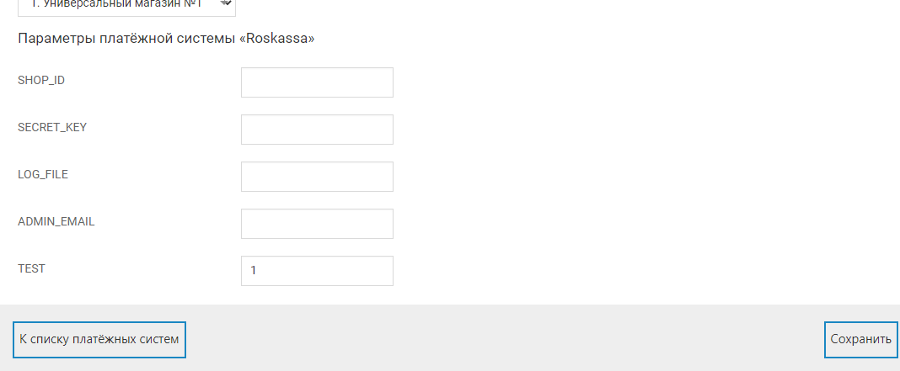

1. Go to the "Online store -> Settings -> Payment" section.

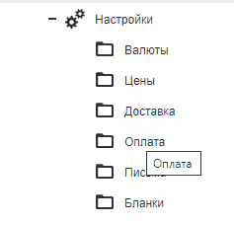

1. Press the "Add" button and select "Roskassa".
2. Configure the module as you need and click "Save".
3. Configure links in your Roskassa personal account:

Notification URL

https://****/netcat/modules/payment/callback.php?paySystem=nc_payment_system_roskassa  
Successful payment URL

http:// ****/netcat/modules/payment/response/roskassa/success.php

Failed paymet URL

http:// ****/netcat/modules/payment/response/roskassa/fail.php